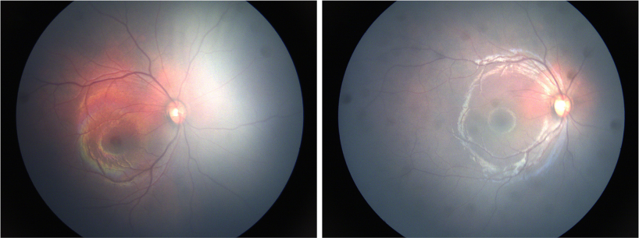

A 2-month-old girl 。 A “tomato catsup” fundus (A) could be observed by RetCam III due todiffuse choroidal hemangioma (DCH). Intraocular pressure (IOP) was 14 mmHg. After using timolol maleate eye drops twice daily for 3months, the DCH shrunk in color fundus image (B). The IOP was 11 mmHg. The patient was advised to maintain treatment with b-blockersand a follow-up visit was recommended. Based on the provided images and clinical description please make an ophthalmic diagnosis for this patient. And output the diagnostic conclusions only.

**Diffuse choroidal hemangioma (DCH)**